**DBMS Tutorial**

What is Database

Types of Databases

What is RDBMS

DBMS vs RDBMS

DBMS vs File System

DBMS Architecture

ACID Properties in DBMS

**Data modeling**

ER model concept

Notation for ER diagram

ER Design Issues

DBMS Keys

**Normalization**

Normalization DBMS 1NFDBMS 2NFDBMS 3NFDBMS BCNFDBMS 4NFDBMS 5NF

**SQL Introduction**

SQL Introduction

Characteristics of SQL

Advantage of SQL

SQl Datatype

SQL Command

SQL Operator

SQL Table

SQL SELECT Statement

SQL INSERT Statement

SQL Update Statement

SQL DELETE Statement

SQL View

SQL Index

SQL Sub Queries

SQL Clauses

SQL Aggregate Function

SQL JOIN

SQL Set Operation

Fundamentals of Database

• What is Data Base and Why is Data Base?

• DBMS Concepts

• RDBMS Concepts

• Oracle versions

• What is oracle 12c?

KEY Constraints

What is SQL?

Oracle data types

SQL LANGUAGES Data Definition Language (DDL) Commands

• CREATE

• ALTER

• TRUNCATE

• DROP

RENAME Data Manipulation Languages(DML) Commands

• INSERT

• UPDATE

DELETE Data Query Language / Retrieval Language DRL DQL

• SELECT

Transaction Control Languages(TCL) Commands

• ROLLBACK

• COMMIT

• SAVEPOINT Data Control Languages(DCL) Commands

• GRANT

• REVOKE

Joins in DBMS | SQL

Inner Joins in DBMS | SQL

Outer Join in DBMS | SQL

Left Join in DBMS | SQL

Right Join in DBMS | SQL

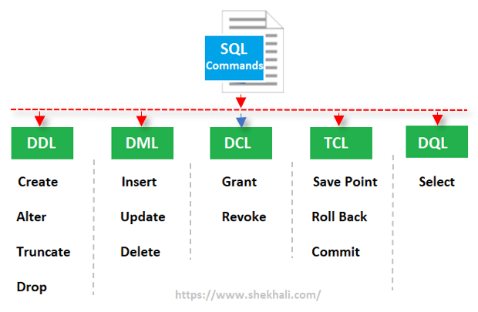

**Types of SQL Commands**

The following is the list of five widely used SQL Commands.

* DDL (Data Definition Language)
* DML (Data Manipulation Language)
* DCL (Data Control Language)
* TCL (Transaction Control Language)
* DQL (Data Query Language)

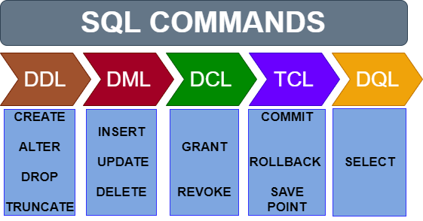

#### Types of SQL Commands:

* DDL – Data Definition Language
* DML – Data Manipulation Language
* DCL – Data Control Language
* DQL – Data Query Language
* TCL – Transaction Control Language

## What is SQL?

**SQL** is a database language designed for the retrieval and management of data in a relational database.

SQL is the standard language for database management. All the RDBMS systems like MySQL, MS Access, Oracle, Sybase, Postgres, and SQL Server use SQL as their standard database language. SQL programming language uses various commands for different operations. We will learn about the like DCL, TCL, DQL, DDL and DML commands in SQL with examples.

## Why Use SQL?

Here, are important reasons for using SQL

* It helps users to access data in the RDBMS system.
* It helps you to describe the data.
* It allows you to define the data in a database and manipulate that specific data.
* With the help of SQL commands in DBMS, you can create and drop databases and tables.
* SQL offers you to use the function in a database, create a view, and stored procedure.
* You can set permissions on tables, procedures, and views.

## Brief History of SQL

Here, are important landmarks from the history of SQL:

* 1970 – Dr. Edgar F. “Ted” Codd described a relational model for databases.
* 1974 – Structured Query Language appeared.
* 1978 – IBM released a product called System/R.
* 1986 – IBM developed the prototype of a relational database, which is standardized by ANSI.
* 1989- First ever version launched of SQL
* 1999 – SQL 3 launched with features like triggers, object-orientation, etc.
* SQL2003- window functions, XML-related features, etc.
* SQL2006- Support for XML Query Language
* SQL2011-improved support for temporal databases

## Types of SQL

Here are five types of widely used SQL queries.

* Data Definition Language (DDL)
* Data Manipulation Language (DML)
* Data Control Language(DCL)
* Transaction Control Language(TCL)
* Data Query Language (DQL)

## DCL(Data Control Language)

It deals with the permissions and privileges of the objects. Two DCL commands are

GRANT – Provides user access to the database or its objects.

REVOKE – Restricts the user access to the database or its objects.

## TCL(Transaction Control Language)

It deals with the transaction within the database. Some of the TCL commands are

COMMIT – Used to store the changes performed using a transaction.

ROLLBACK – Used to revert the changes up to the last committed state in case of any error.

SAVEPOINT – Used to roll the transaction back to a certain point.

#### DDL (Data Definition Language) :

Data Definition Language is used to define the database structure or schema. DDL is also used to specify additional properties of the data. The storage structure and access methods used by the database system by a set of statements in a special type of DDL called a data storage and definition language. These statements define the implementation details of the database schema, which are usually hidden from the users. The data values stored in the database must satisfy certain consistency constraints.

CREATE : to create objects in database

ALTER : alters the structure of database

DROP : delete objects from database

RENAME : rename an objects

#### DML (Data Manipulation Language) :

DML statements are used for managing data with in schema objects.   
DML are of two types

SELECT: retrieve data from the database

INSERT: insert data into a table

UPDATE: update existing data within a table

DELETE: deletes all records from a table, space for the records remain

#### TCL (Transaction Control Language) :

Transaction Control Language commands are used to manage transactions in the database. These are used to manage the changes made by DML-statements. It also allows statements to be grouped together into logical transactions.

Examples of TCL commands –

COMMIT: Commit command is used to permanently save any transaction

into the database.

ROLLBACK: This command restores the database to last committed state.

It is also used with savepoint command to jump to a savepoint

in a transaction.

SAVEPOINT: Savepoint command is used to temporarily save a transaction so

that you can rollback to that point whenever necessary.

#### DCL (Data Control Language) :

A Data Control Language is a syntax similar to a computer programming language used to control access to data stored in a database (Authorization). In particular, it is a component of Structured Query Language (SQL).

Examples of DCL commands : 

GRANT: allow specified users to perform specified tasks.

REVOKE: cancel previously granted or denied permissions.

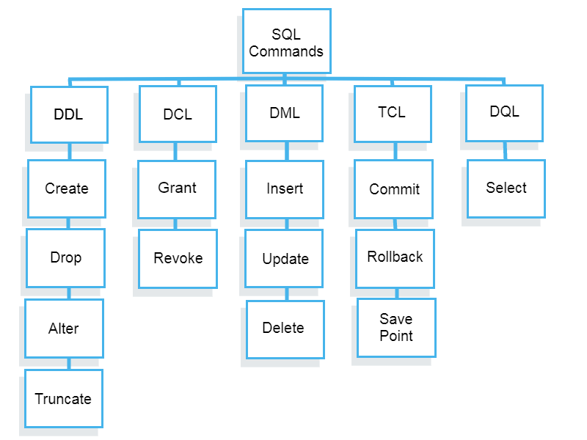

## What is DDL?

Data Definition Language helps you to define the database structure or schema. Let’s learn about DDL commands with syntax.

Five types of DDL commands in SQL are:

### CREATE

CREATE statements is used to define the database structure schema:

**Syntax:**

CREATE TABLE TABLE_NAME (COLUMN_NAME DATATYPES[,....]);

**For example**:

Create database university;

Create table students;

Create view for_students;

### DROP

Drops commands remove tables and databases from RDBMS.

Syntax

DROP TABLE ;

**For example:**

Drop object_type object_name;

Drop database university;

Drop table student;

### ALTER

Alters command allows you to alter the structure of the database.

**Syntax:**

To add a new column in the table

ALTER TABLE table_name ADD column_name COLUMN-definition;

To modify an existing column in the table:

ALTER TABLE MODIFY(COLUMN DEFINITION....);

**For example:**

Alter table guru99 add subject varchar;

### TRUNCATE:

This command used to delete all the rows from the table and free the space containing the table.

**Syntax:**

TRUNCATE TABLE table_name;

**Example:**

TRUNCATE table students;

## What is Data Manipulation Language?

Data Manipulation Language (DML) allows you to modify the database instance by inserting, modifying, and deleting its data. It is responsible for performing all types of data modification in a database.

There are three basic constructs which allow database program and user to enter data and information are:

Here are some important DML commands in SQL:

* INSERT
* UPDATE
* DELETE

### INSERT:

This is a statement is a SQL query. This command is used to insert data into the row of a table.

**Syntax:**

INSERT INTO TABLE_NAME (col1, col2, col3,.... col N)

VALUES (value1, value2, value3, .... valueN);

Or

INSERT INTO TABLE_NAME

VALUES (value1, value2, value3, .... valueN);

**For example:**

INSERT INTO students (RollNo, FIrstName, LastName) VALUES ('60', 'Tom', Erichsen');

### UPDATE:

This command is used to update or modify the value of a column in the table.

**Syntax:**

UPDATE table_name SET [column_name1= value1,...column_nameN = valueN] [WHERE CONDITION]

**For example:**

UPDATE students

SET FirstName = 'Jhon', LastName= 'Wick'

WHERE StudID = 3;

### DELETE:

This command is used to remove one or more rows from a table.

**Syntax:**

DELETE FROM table_name [WHERE condition];

**For example:**

DELETE FROM students

WHERE FirstName = 'Jhon';

## What is DCL?

DCL (Data Control Language) includes commands like GRANT and REVOKE, which are useful to give “rights & permissions.” Other permission controls parameters of the database system.

### Examples of DCL commands:

Commands that come under DCL:

* Grant
* Revoke

### Grant:

This command is use to give user access privileges to a database.

**Syntax:**

GRANT SELECT, UPDATE ON MY_TABLE TO SOME_USER, ANOTHER_USER;

**For example:**

GRANT SELECT ON Users TO'Tom'@'localhost;

### Revoke:

It is useful to back permissions from the user.

**Syntax:**

REVOKE privilege_nameON object_nameFROM {user_name |PUBLIC |role_name}

**For example:**

REVOKE SELECT, UPDATE ON student FROM BCA, MCA;

## What is TCL?

Transaction control language or TCL commands deal with the transaction within the database.

### Commit

This command is used to save all the transactions to the database.

**Syntax:**

Commit;

**For example:**

DELETE FROM Students

WHERE RollNo =25;

COMMIT;

### Rollback

Rollback command allows you to undo transactions that have not already been saved to the database.

**Syntax:**

ROLLBACK;

**Example:**

DELETE FROM Students

WHERE RollNo =25;

### SAVEPOINT

This command helps you to sets a savepoint within a transaction.

**Syntax:**

SAVEPOINT SAVEPOINT_NAME;

**Example:**

SAVEPOINT RollNo;

* SQL is a database language designed for the retrieval and management of data in a relational database.
* It helps users to access data in the RDBMS system
* In the year 1974, the term Structured Query Language appeared
* Five types of SQL queries are 1) Data Definition Language (DDL) 2) Data Manipulation Language (DML) 3) Data Control Language(DCL) 4) Transaction Control Language(TCL) and, 5) Data Query Language (DQL)
* Data Definition Language(DDL) helps you to define the database structure or schema.
* Data Manipulation Language (DML) allows you to modify the database instance by inserting, modifying, and deleting its data.
* DCL (Data Control Language) includes commands like GRANT and REVOKE, which are useful to give “rights & permissions.”
* Transaction control language or TCL commands deal with the transaction within the database.
* Data Query Language (DQL) is used to fetch the data from the [database](https://www.guru99.com/introduction-to-database-sql.html).

https://www.guru99.com/sql-commands-dbms-query.html

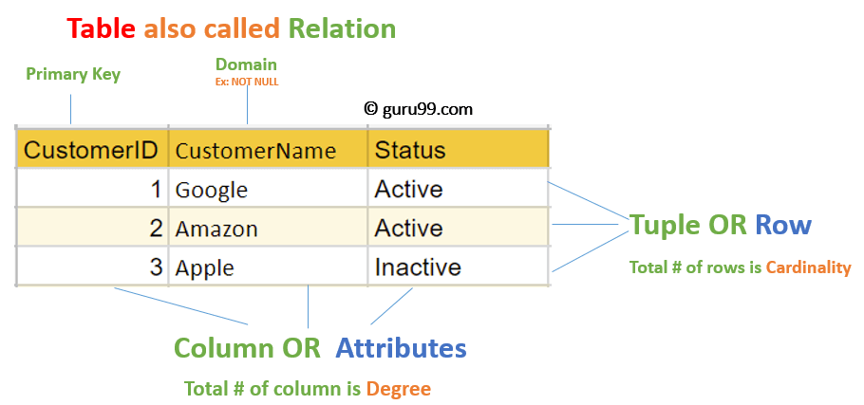

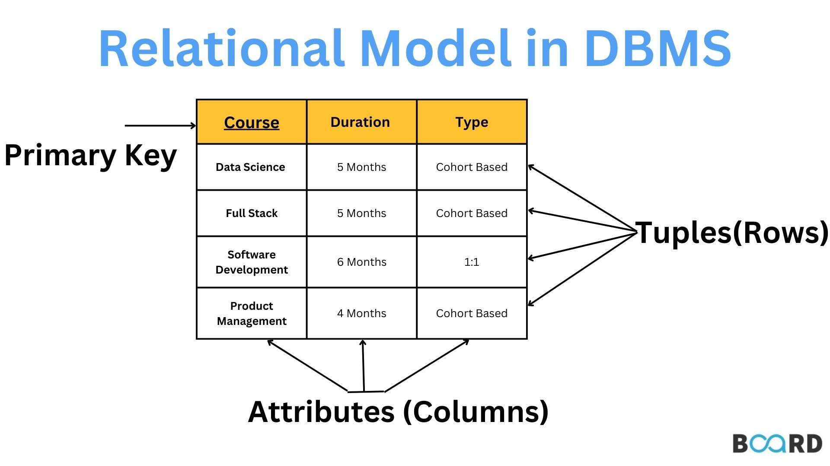

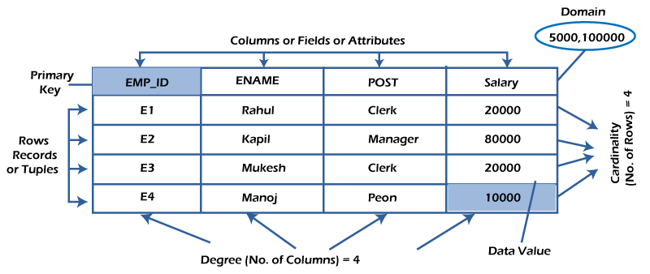

* **Relation:** A two-dimensional table that is used to hold a group of data pieces.
* **Tuple:** Row of the relation, representing an actual thing.
* **Attribute or Field:** The relation's column displays the properties that make up the relationship.
* **Attribute Domain:**The set of predefined atomic values that an attribute can take, or the "attribute domain," outlines the permitted values for an attribute.
* **Degree:**The total number of attributes contained in the relation is the attribute count.
* **Cardinality:** A relation's cardinality, or the total number of rows it contains, indicates the number of entities that are engaged in the relationship.
* **The relational schema**, which explains the structure and design of the relation, is its logical blueprint. The name of the table, along with the attributes' kinds, are all included:

## Best Practices for creating a Relational Model

* Data need to be represented as a collection of relations
* Each relation should be depicted clearly in the table
* Rows should contain data about instances of an entity
* Columns must contain data about attributes of the entity
* Cells of the table should hold a single value
* Each column should be given a unique name
* No two rows can be identical
* The values of an attribute should be from the same domain